[www.wvu-ncc.com](http://www.wvu-ncc.com)

Dear Fellow WVU Alum:

Thanks for your continued interest in WVU. Below is the 2025 membership form. As you consider renewing your membership, keep in mind that a significant portion of your dues will be donated to the chapter scholarship program, which supports Northeast Ohio residents who are attending WVU.

Thank you for your interest and support.

Sincerely,

JB Ullom *President, WVU Alumni Association North Coast Cleveland Chapter*

Complete and return membership application.

NCC ALUMNI CHAPTER MEMBERSHIP APPLICATION

NAME

WVU CLASS YEAR DEGREE/MAJOR

SPOUSE

WVU CLASS YEAR DEGREE/MAJOR

[IF AN ALUMNA, INCLUDE MAIDEN NAME HERE IF APPLICABLE]

HOME MAILING ADDRESS

HOME TELEPHONE HOME EMAIL (PRINT CLEARLY)

EMPLOYER POSITION

WORK TELEPHONE WORK EMAIL (PRINT CLEARLY)

|  |  |  |
| --- | --- | --- |
| Single Membership: | $ | 25 |
| Couple Membership: | $ | 40 |
| *(spouse need not be WVU graduate)* | | |

Make checks payable to:

***ADDITIONAL CONTRIBUTION DONATION:*** $ __________WVU Alumni Assoc. North Coast Cleveland Chapter

|  |  |  |
| --- | --- | --- |
|  |  | Mail to: |
|  |  | NCC Alumni Chapter |
|  |  | P.O. Box 40073 |
| **AMOUNT ENCLOSED:** | **$ __________** | Cleveland, OH 44140-0073 |

**CHECK OUT OUR WEBSITE:** <http://wvu-ncc.com/> **FOLLOW US ON FACEBOOK:** [North Coast Cleveland WVU Alumni](https://www.facebook.com/NorthCoastClevelandWVUAlumni)

***SAVE THE DATE! MARCH 26, 2025***

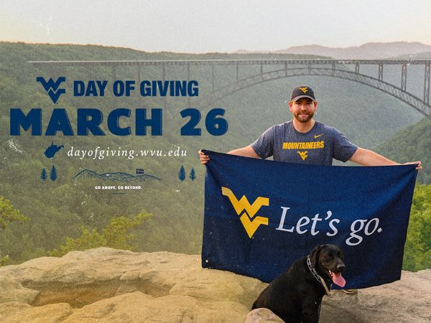

***SCHOLARSHIP CONTRIBUTION OPTION:***

Look for a forthcoming email with information on how you can contribute and support our chapter’s scholarship fund on the WVU Foundation’s annual day of giving.

***#WVUDAYofGIVING***

**CREDIT CARDS ACCEPTED!**

All proceeds to benefit the:

**Stanley E. Friedman North Coast Cleveland**

**Alumni Scholarship Fund**